To begin using HireTouch, create your Account, including Profile information. You will also need to complete the Civil Service Extra Help application package.

Hire Touch Account & Profile  Create Account  - Open browser  - Navigate to https://siue.hiretouch.com  - SIUE Hire Touch log in page will open  - Click  - (If you have already created an account, simply click the Login button) | SIUE Hire Touch Log In Page  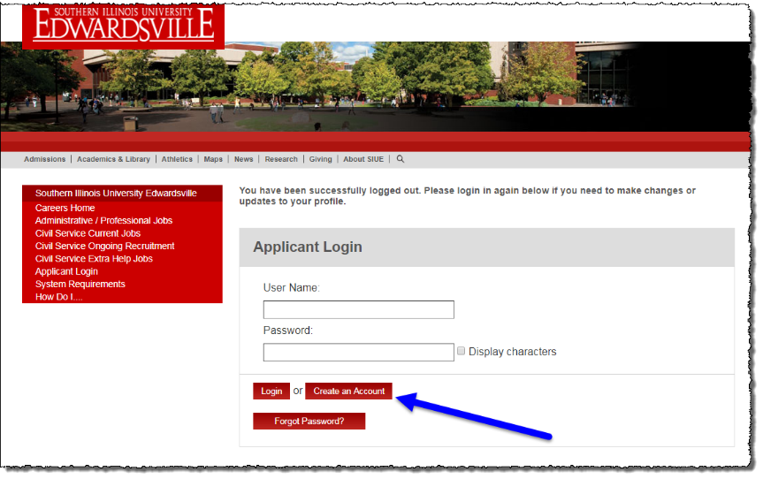
- Profile page opens  - Complete information  - Items with a red asterisk are required  - SIUE University ID (800#) is required for current or past employees and students  - Create your own User Name – Verify that name is available before proceeding (message appears indicating if the User Name is available or not)  - Create your own Password – Confirm that passwords match before proceeding (message appears if passwords do not match)  - Make sure to record your user name and password so you can retrieve it when needed  - Click | Profile Page  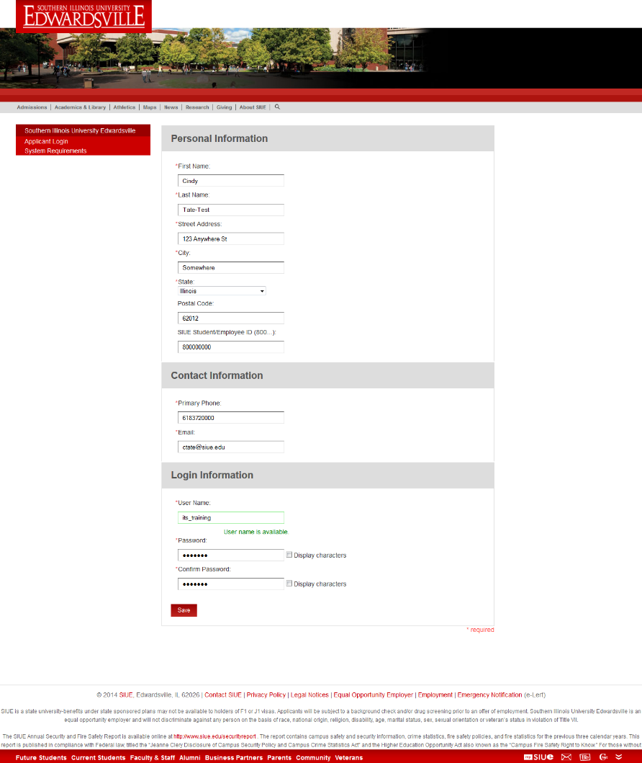
- Open the Extra Help application package  Employment Application  - Complete fields required (marked by a red *) in both sections  - General / Education  - Employment History / Signature and Confirmation  - Some of the information will be prepopulated from your Profile.  - Be sure to select  at the bottom of the page  Employment History  - Add your complete employment history, including any military service  - Select the button for each organization you have been employed by | 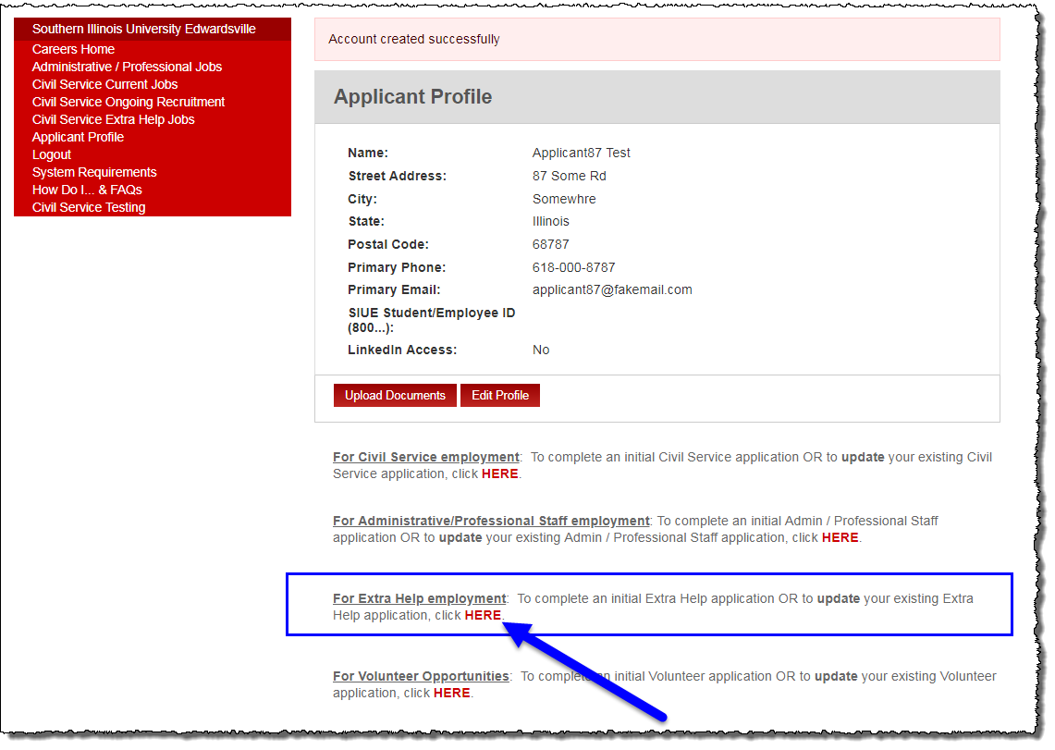  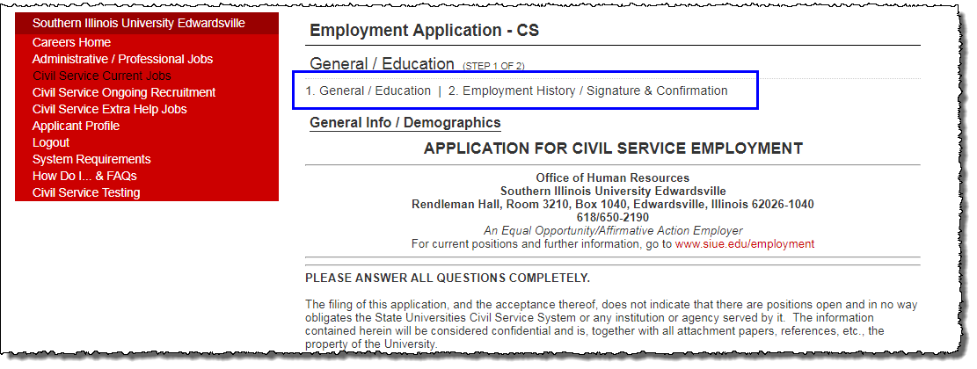  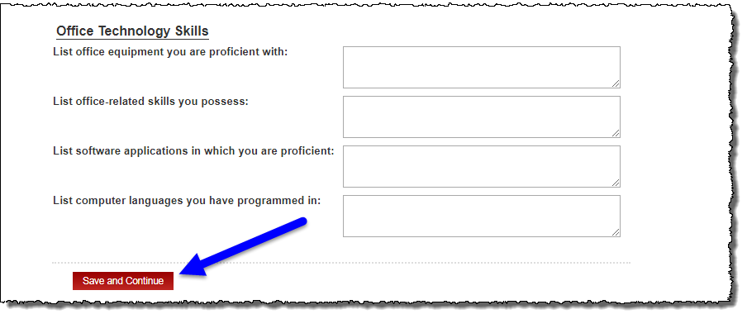  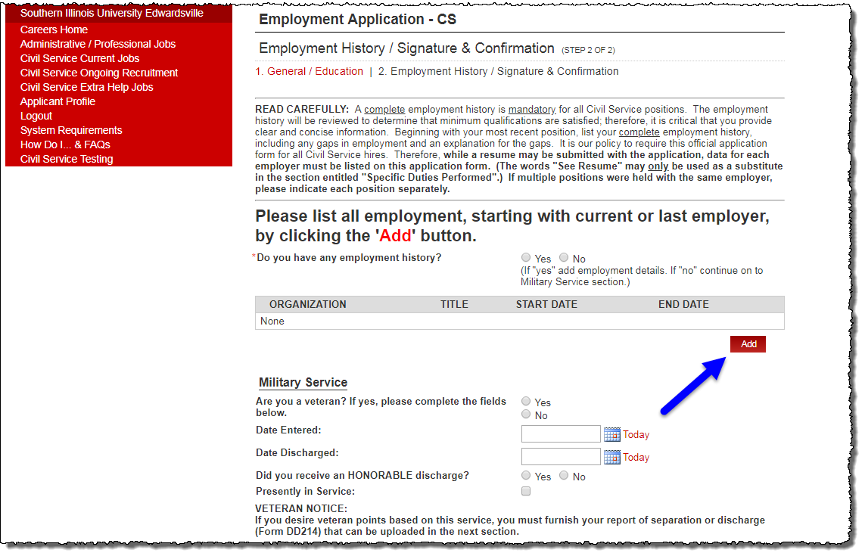

- Select the button for any employers added.  - Check the box to agree to a digital signature  - Type name as your signature  - Be sure to select  at the bottom of the page | 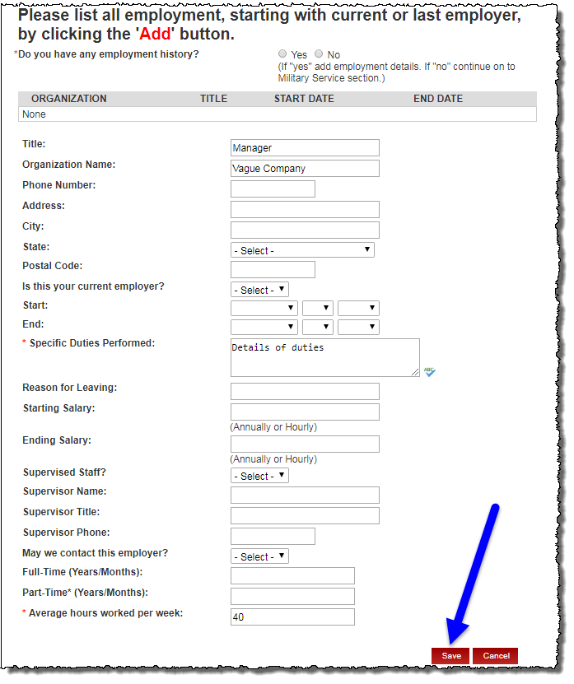  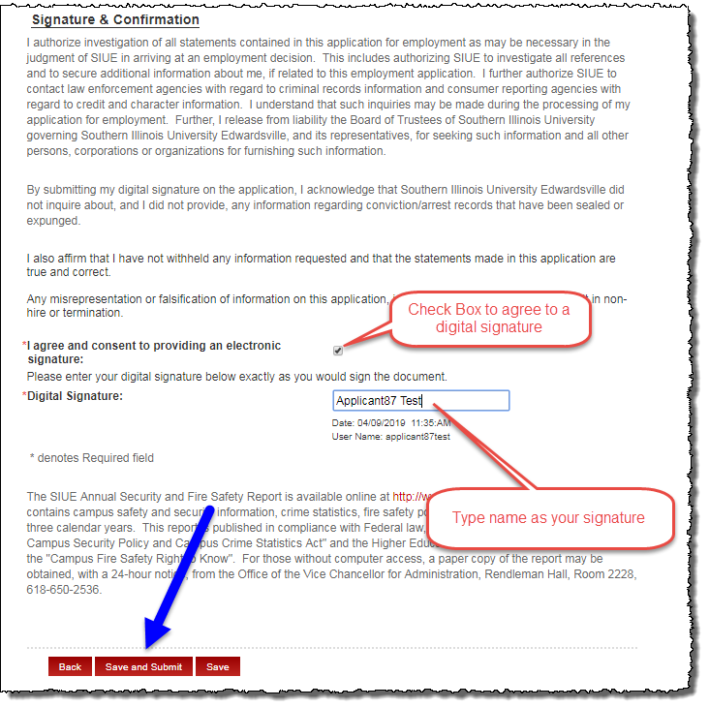
Authorization for Release of Information  Complete form including any required fields  - Select the ‘Add’ button to add any other names used.  - Select the ‘Add’ button to add any addresses associated with you for the last ten years.  - Select the button for any names and addresses added.  - Continue answering remaining questions  - Provide Digital Signature  - Click the button at the bottom of the page.  EMPLOYEE & GRADUATE ASSISTANT DATA COLLECTION & DATA CHANGE FORM  Complete the form including required fields.  - Provide Digital Signature  - Click | 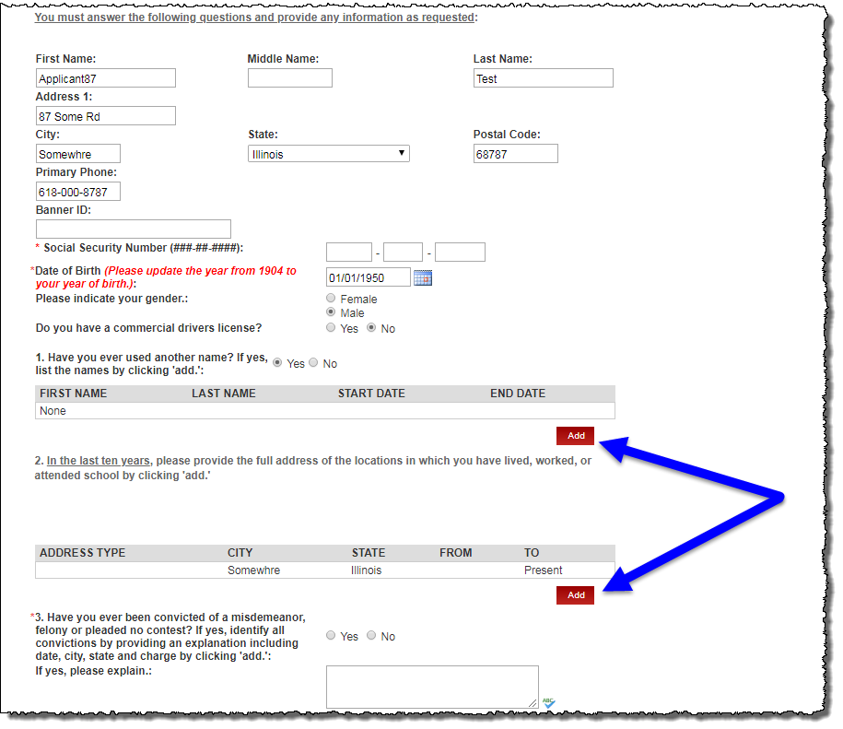  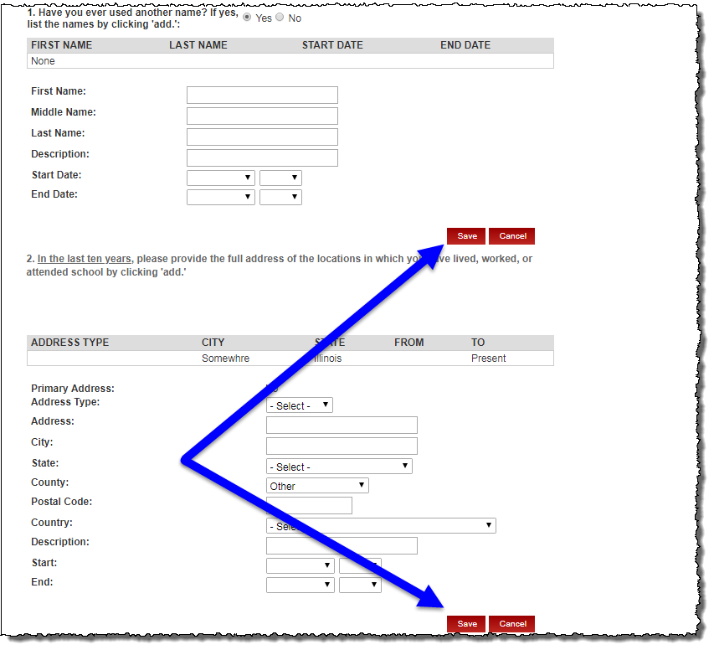  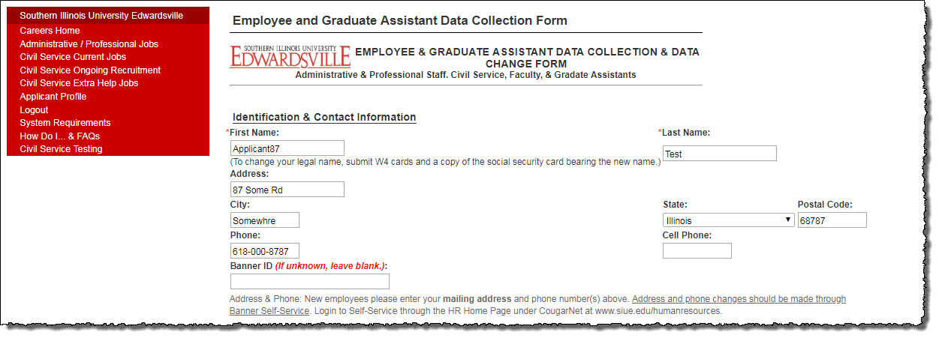  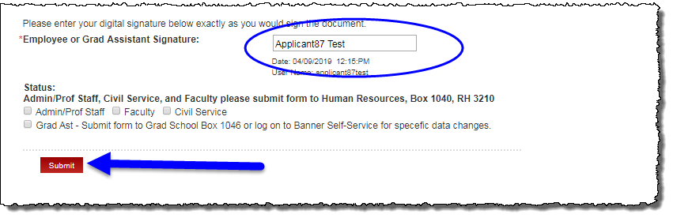

Additional Resources
Phone Numbers
- Human Resources: 650-2190

Web Sites
- Human Resources Employment: http://www.siue.edu/employment
- Human Resources: http://www.siue.edu/human-resources

Email Addresses
- Civil Service Testing Staff: civilserviceapplications@siue.edu

